### Ryan Woodward

100201137

### CPSC 1050: Introduction to Computer Science

# Lab on Abstract Data Types, Algorithms

**Complete this template and submit with D2L.**

Applet: <http://faculty.mc3.edu/pvetere/Applets/>

## (refer to LAB 9B of your book)

## Exercise 1 (5 marks)

url: <http://faculty.mc3.edu/pvetere/Applets/APPLETS/SORT/applet_frame.htm>

3. [2 marks] Record the sorting results.

|  |  |  |  |  |
| --- | --- | --- | --- | --- |
|  | Ex 1 | Ex 2 | Ex 3 | Ex 4 |
| Selection | 28 | 120 | 120 | 120 |
| Bubble | 27 | 75 | 15 | 120 |
| Quicksort | 26 | 66 | 150 | 132 |

Steps

1. Choose “Example 1”
2. Choose “Selection Sort” under Algorithm
3. Click sort (button)
4. Repeat the steps for the other Examples and Sort algorithm (Selection, Bubble, Quicksort)

Example output

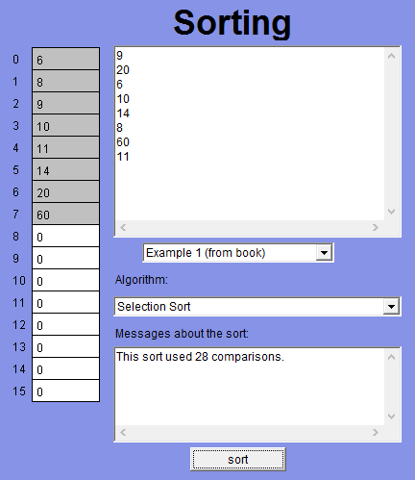

4. [1 mark] Which algorithm is usually the fastest?

* **Quicksort is normally the fastest algorithm. In the already sorted above where we see that the numbers are already sorted, or sorted in the reverse order it performs poorly. However the probability of these situations are low, in most cases the numbers given would be in a random orderl**

5. [1 mark] Is any one algorithm always faster than the others?

* **There is no one instance where one algorithm is faster then the others in all situations.**

6. [1 mark] Are any 2 algorithms similar?

* **The algorithms selection sort and bubble sort perform their duties similarly. Bubble sort compares two numbers next to each other to determine the order, whereas selection sort will compare the first number with each number in the list to determine the order. In each case it can be determined that this is brute force approach.**

## Exercise 2(5 marks)

url: <http://faculty.mc3.edu/pvetere/Applets/APPLETS/SORT/applet_frame.htm>

3. [1 mark]

1. In the text area where it says "Your data set goes here," remove the text and type in these numbers. Press return after every number except the last.

1

99

2

98

3

97

4

96

5

95

6

94

7

93

8

Example

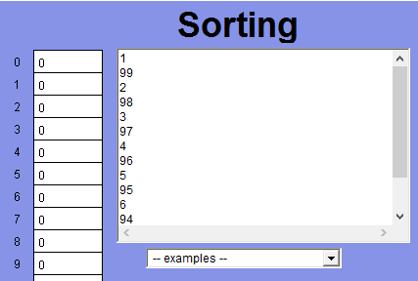

Are these numbers sorted? Are they arranged randomly? What will the final sorted list look like?

**In this case these numbers are not sorted, they are arranged randomly. Although a pattern is definitely recognizable we can still considerate it being sorted randomly due to the fact that it isn't a definitive ascending or descending order. The final list will be sorted like**

**1**

**2**

**3**

**4**

**5**

**6**

**7**

**8**

**93**

**94**

**95**

**96**

**97**

**98**

**99**

4. [3 marks]

You the three sorting algorithms and write down how many comparisons they required to finish the job

Selection sort: **105**

Bubble sort: **105**

Quicksort: **73**

5. [1 mark] Which is the fastest?

* **The quicksort algorithm is the fastest in this situation**

## Exercise 3(5 marks)

url: <http://faculty.mc3.edu/pvetere/Applets/APPLETS/SORT/applet_frame.htm>

3. [1 mark]

In the text area where it says "Your data set goes here," remove the text and type in these numbers. Press return after every number except the last.

1

3

8

15

26

45

50

97

92

84

79

72

70

68

51

Example

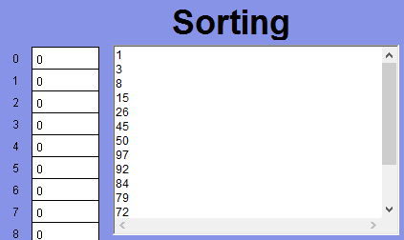

Are these numbers sorted? Are they arranged randomly? What will the final sorted list look like?

* **In this case a definite pattern is emergent as the numbers are ascending to the highest number (97) and then descends back down again. I would not say that they are arranged randomly. The final sorted list will look like**

**1**

**3**

**8**

**15**

**26**

**45**

**50**

**51**

**68**

**70**

**72**

**79**

**84**

**92**

**97**

4. [3 marks]

Use the three sorting algorithms and write down how many comparisons they required to finish the job

Selection sort: **105**

Bubble sort: **84**

Quicksort: **133**

5. [1 mark] Which is the fastest?

* **In this case bubble sort was the fastest given the way that the numbers were structured.**

## Exercise 4(6 marks)

url: <http://faculty.mc3.edu/pvetere/Applets/APPLETS/SEARCH/applet_frame.htm>

2. [4 marks]

Write down how many comparisons

____ Ex 1: Something in the list (sequential)

* **Searched for 62**
* **Found in cell 7 after 8 tries**

____ Ex 2: Something not in the list (sequential)

* **Not found after 16 tries**

____ Ex 3: Something in the list (binary)

* **Searched for 62**
* **Found in cell 7 after 1 try**

____ Ex 4: Something not in the list (binary)

* **Not found after 5 tries**

3. [1 mark]

a. Select Example 3: Something in the list (binary)

Select “binary search” as your algorithm and try to find 62.

How many tries does it need to find it?

* **Found in cell 7 after 1 try**

4. [1 mark] Try to find 62 using sequential search. How many tries does it need?

* **Found in cell 7 after 8 tries**